









**Source code:**

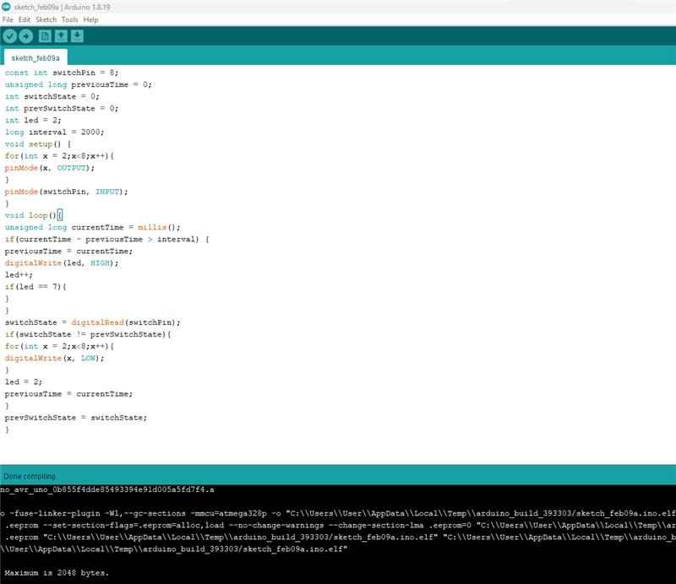

**Simulation:**

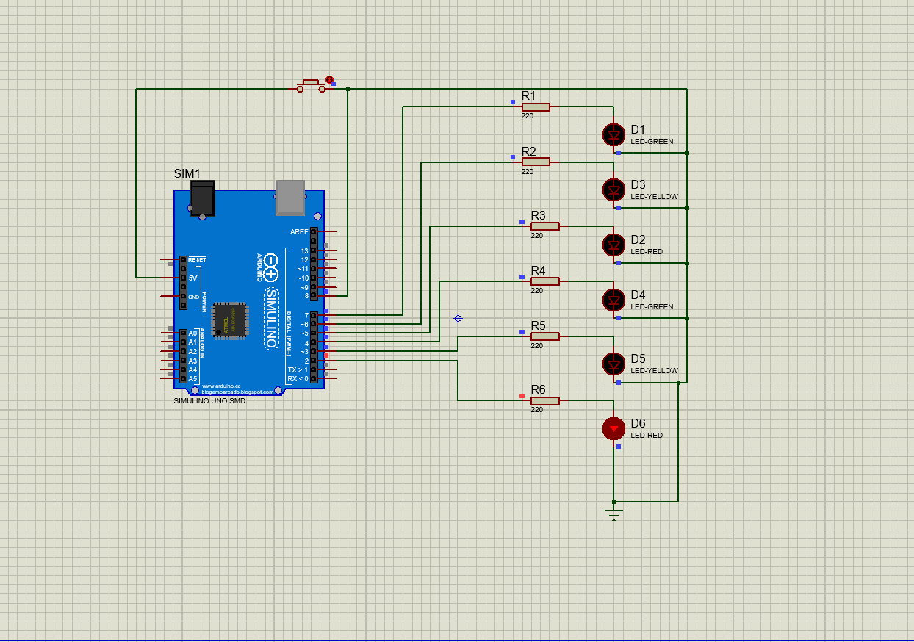

Figure: 1st LED is On

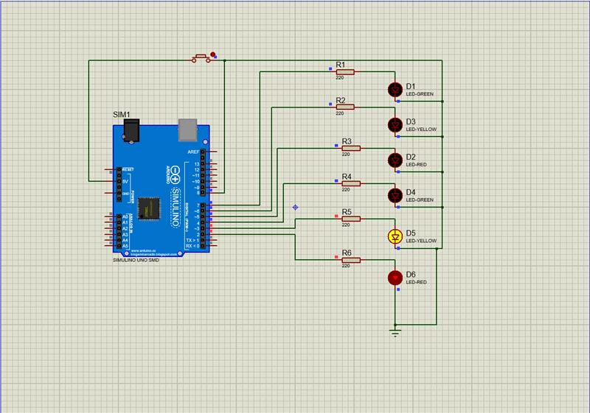

Figure: 2nd LED is On

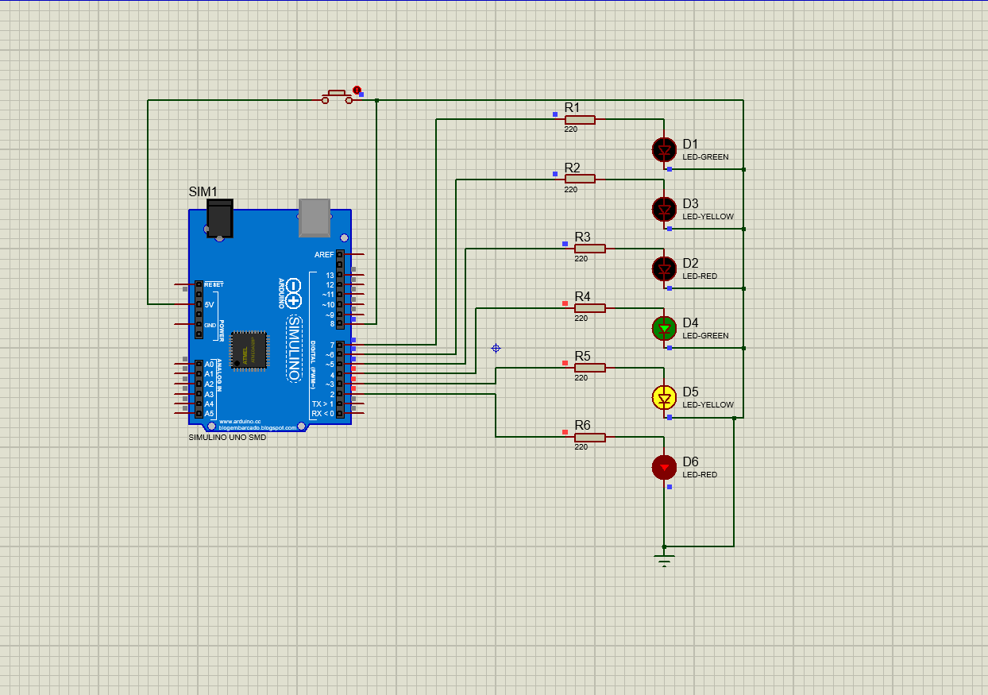

Figure: 3rd LED is On

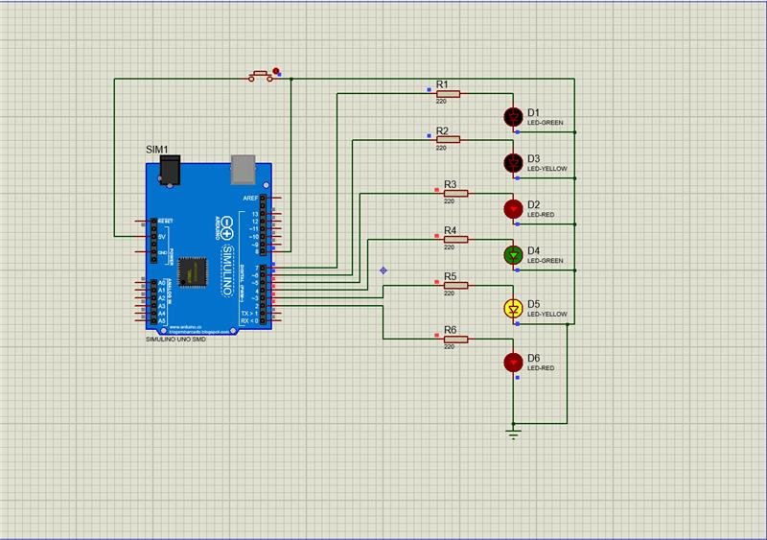

Figure: 4th LED is On

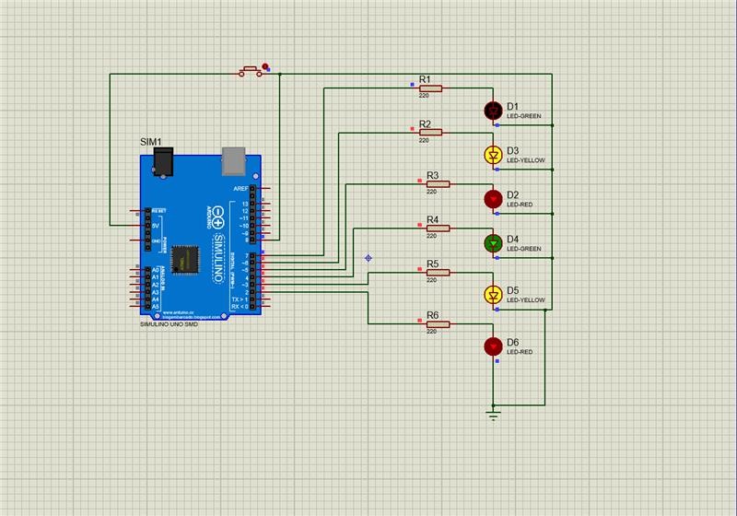

Figure: 5th LED is On

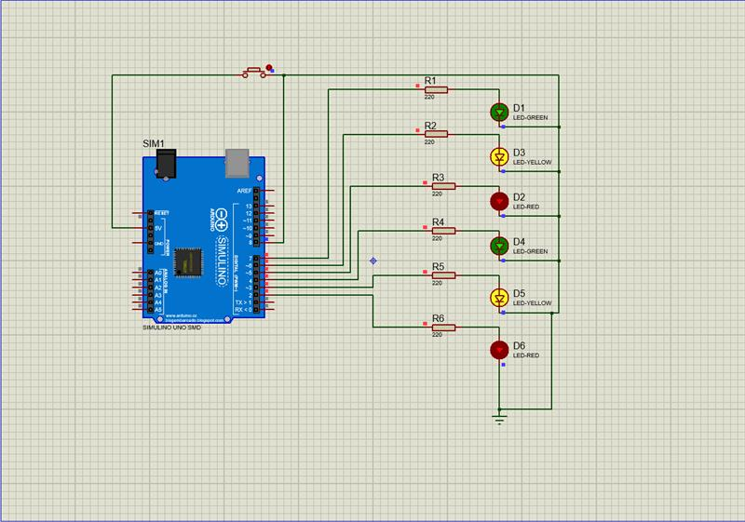

Figure: 6th LED is On

**sHardware Implementation:**

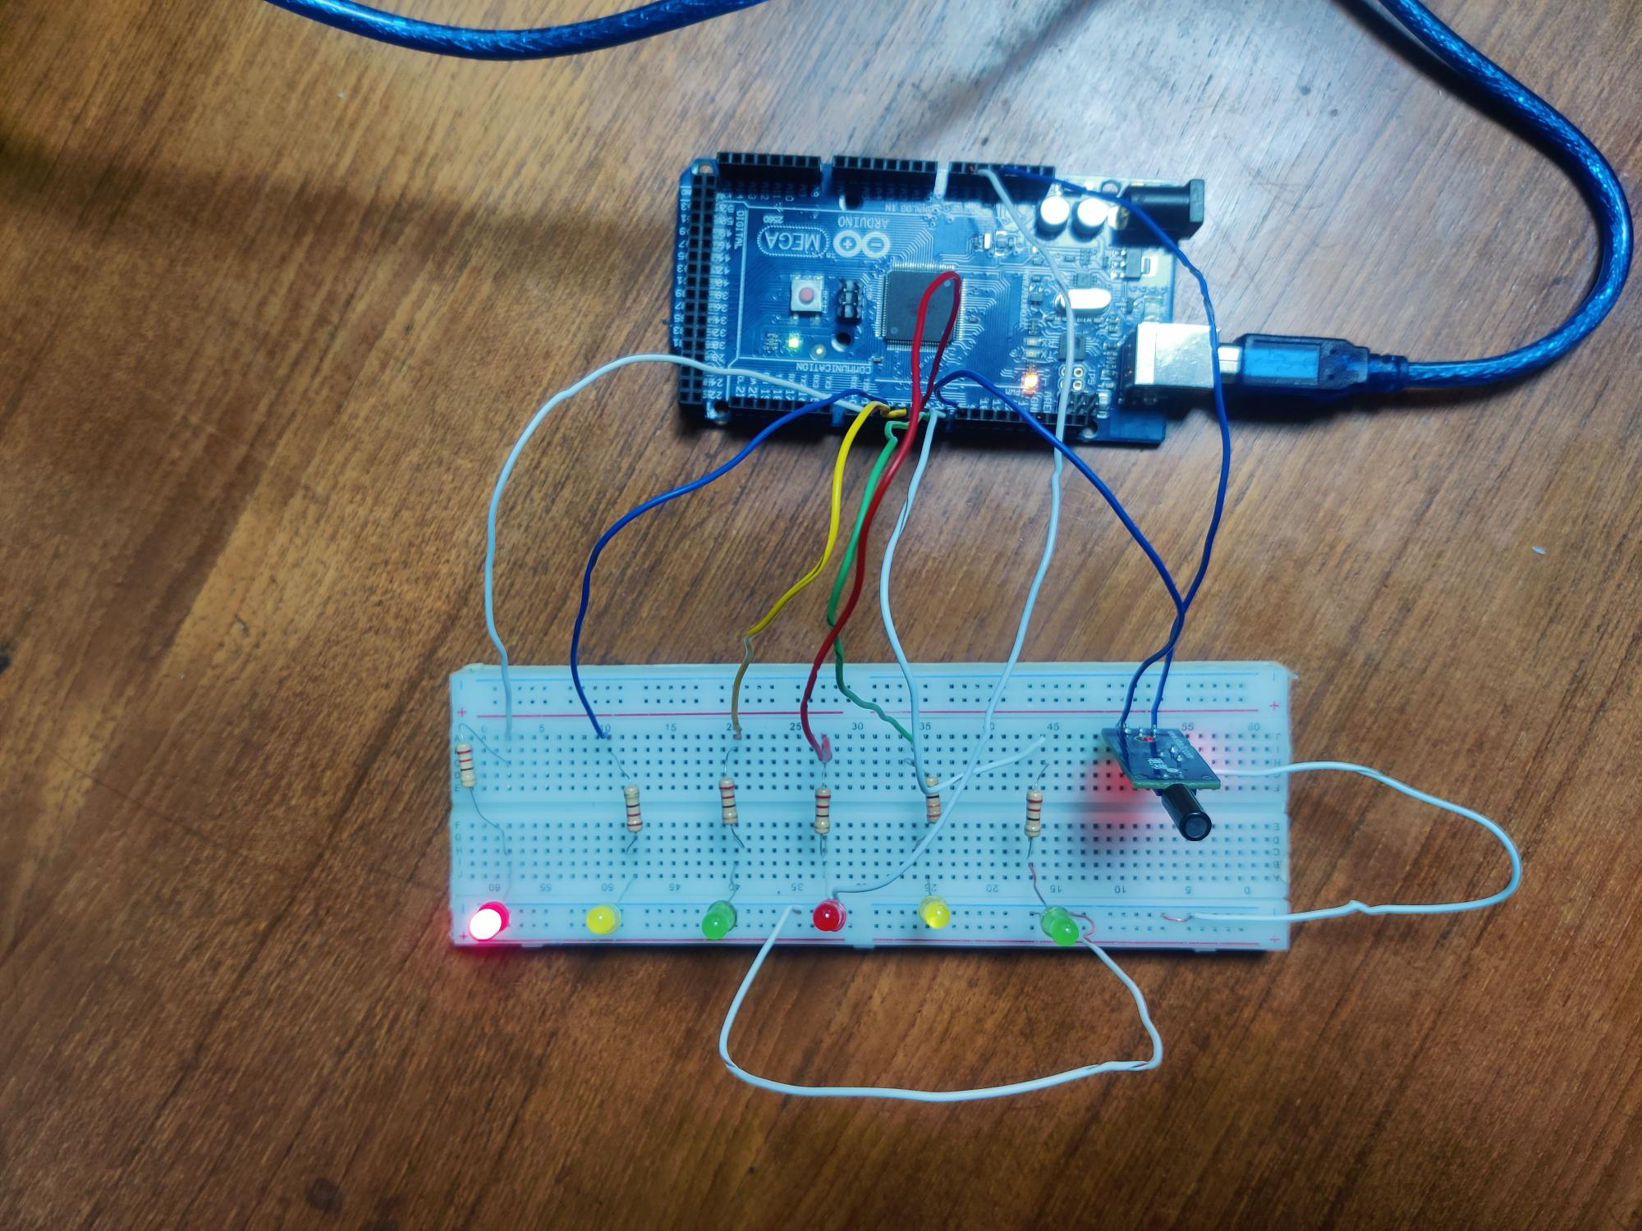

Figure: 1st LED is On

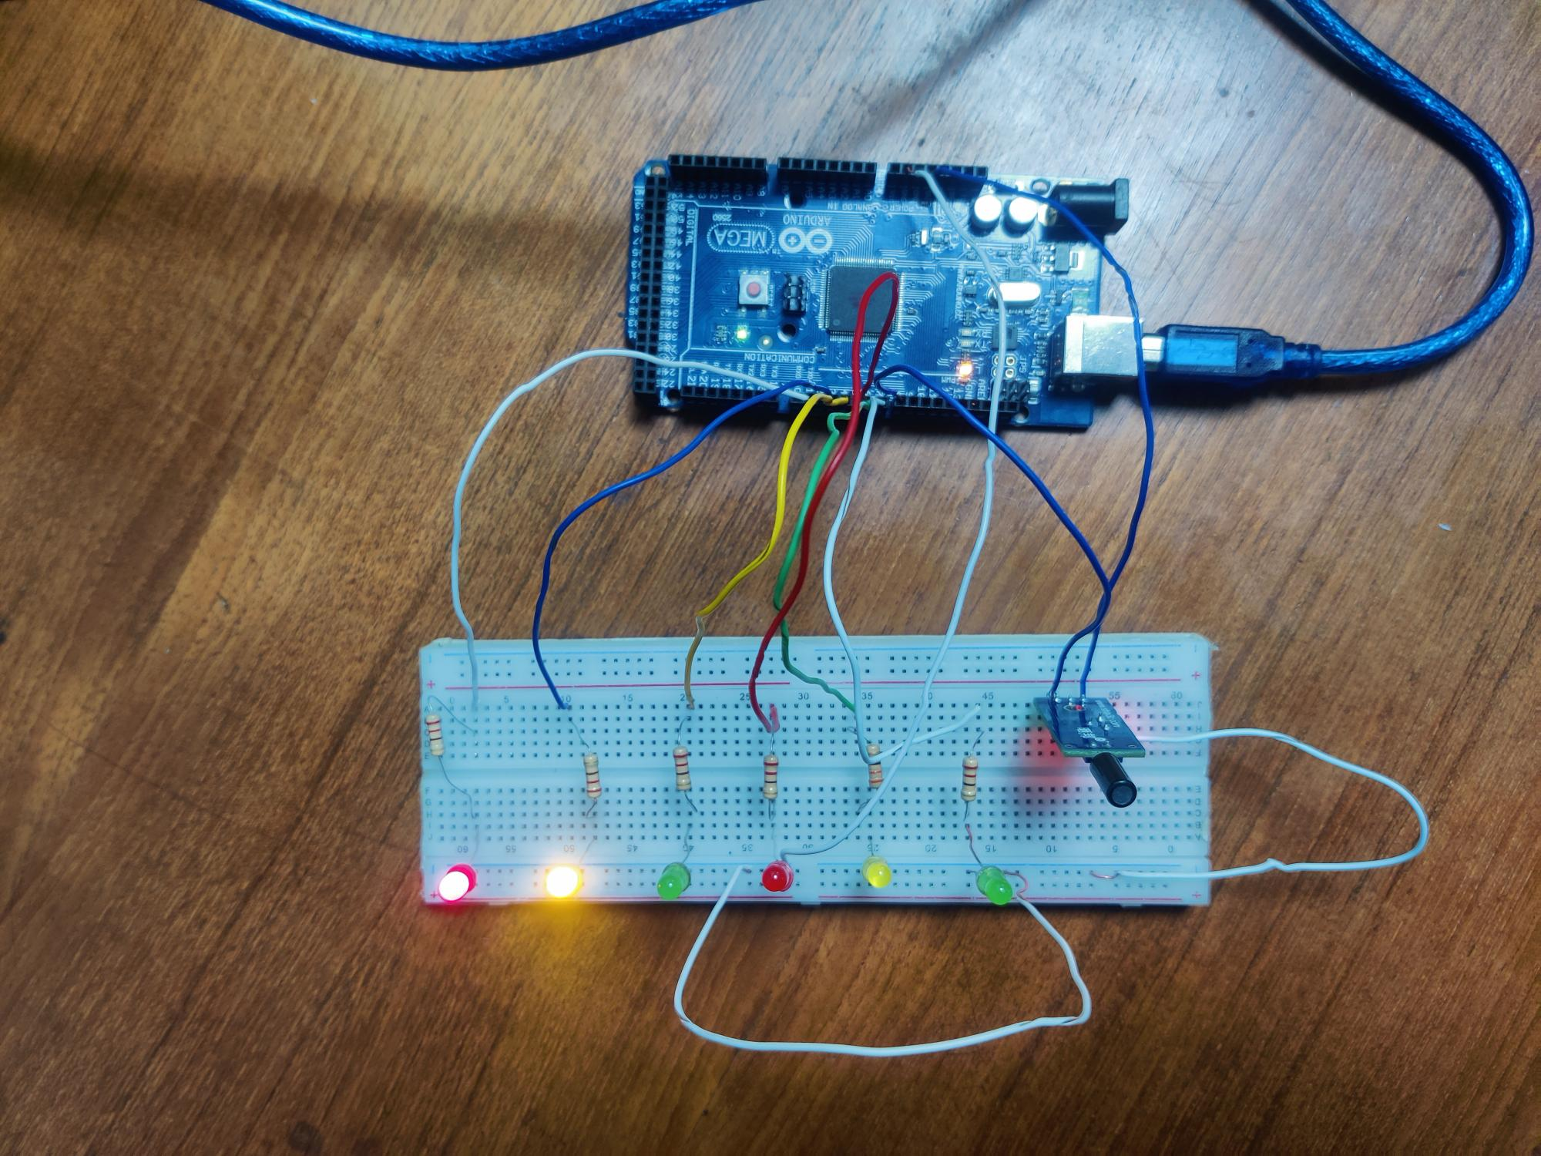

Figure: 2nd LED is On

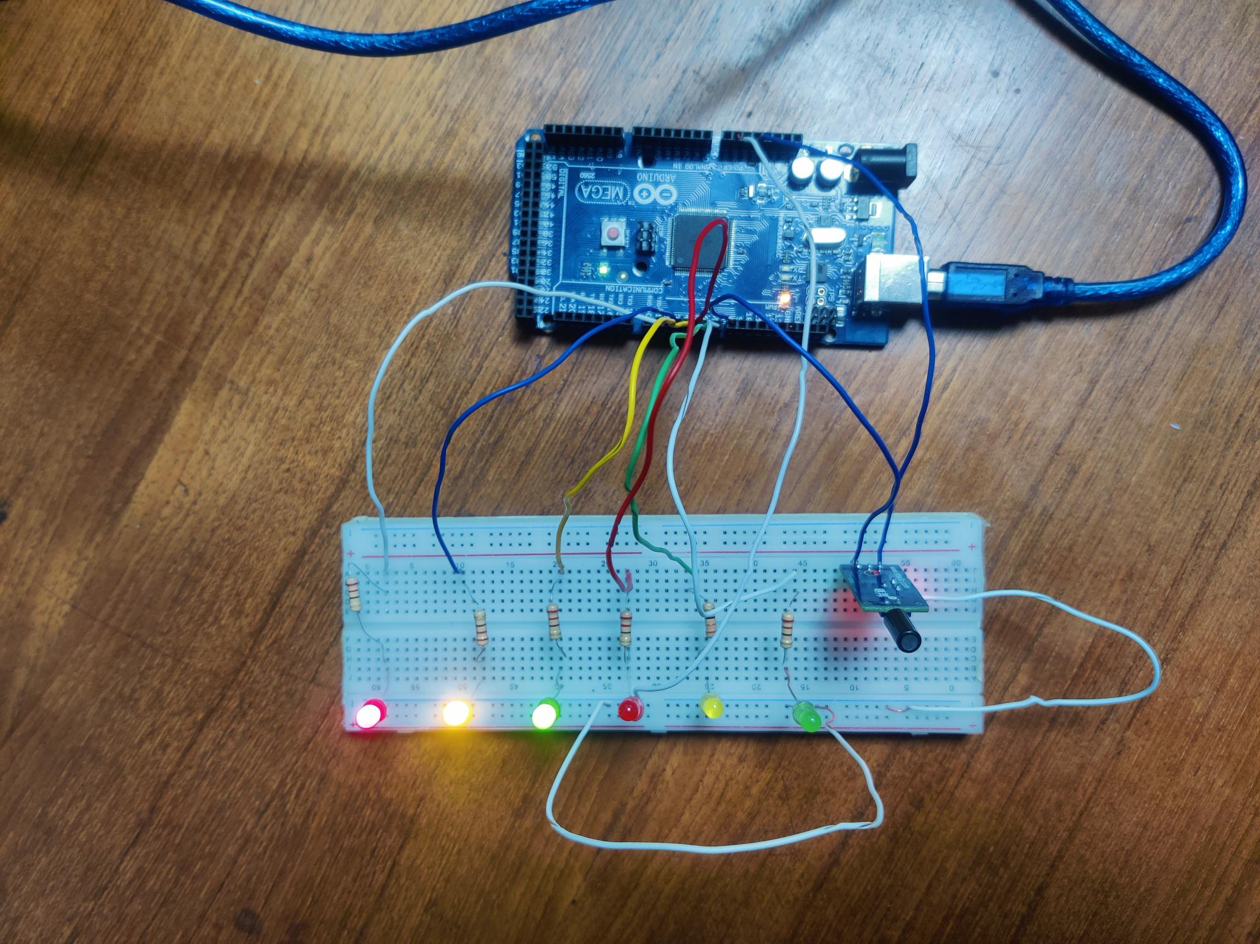

Figure: 3rd LED is On

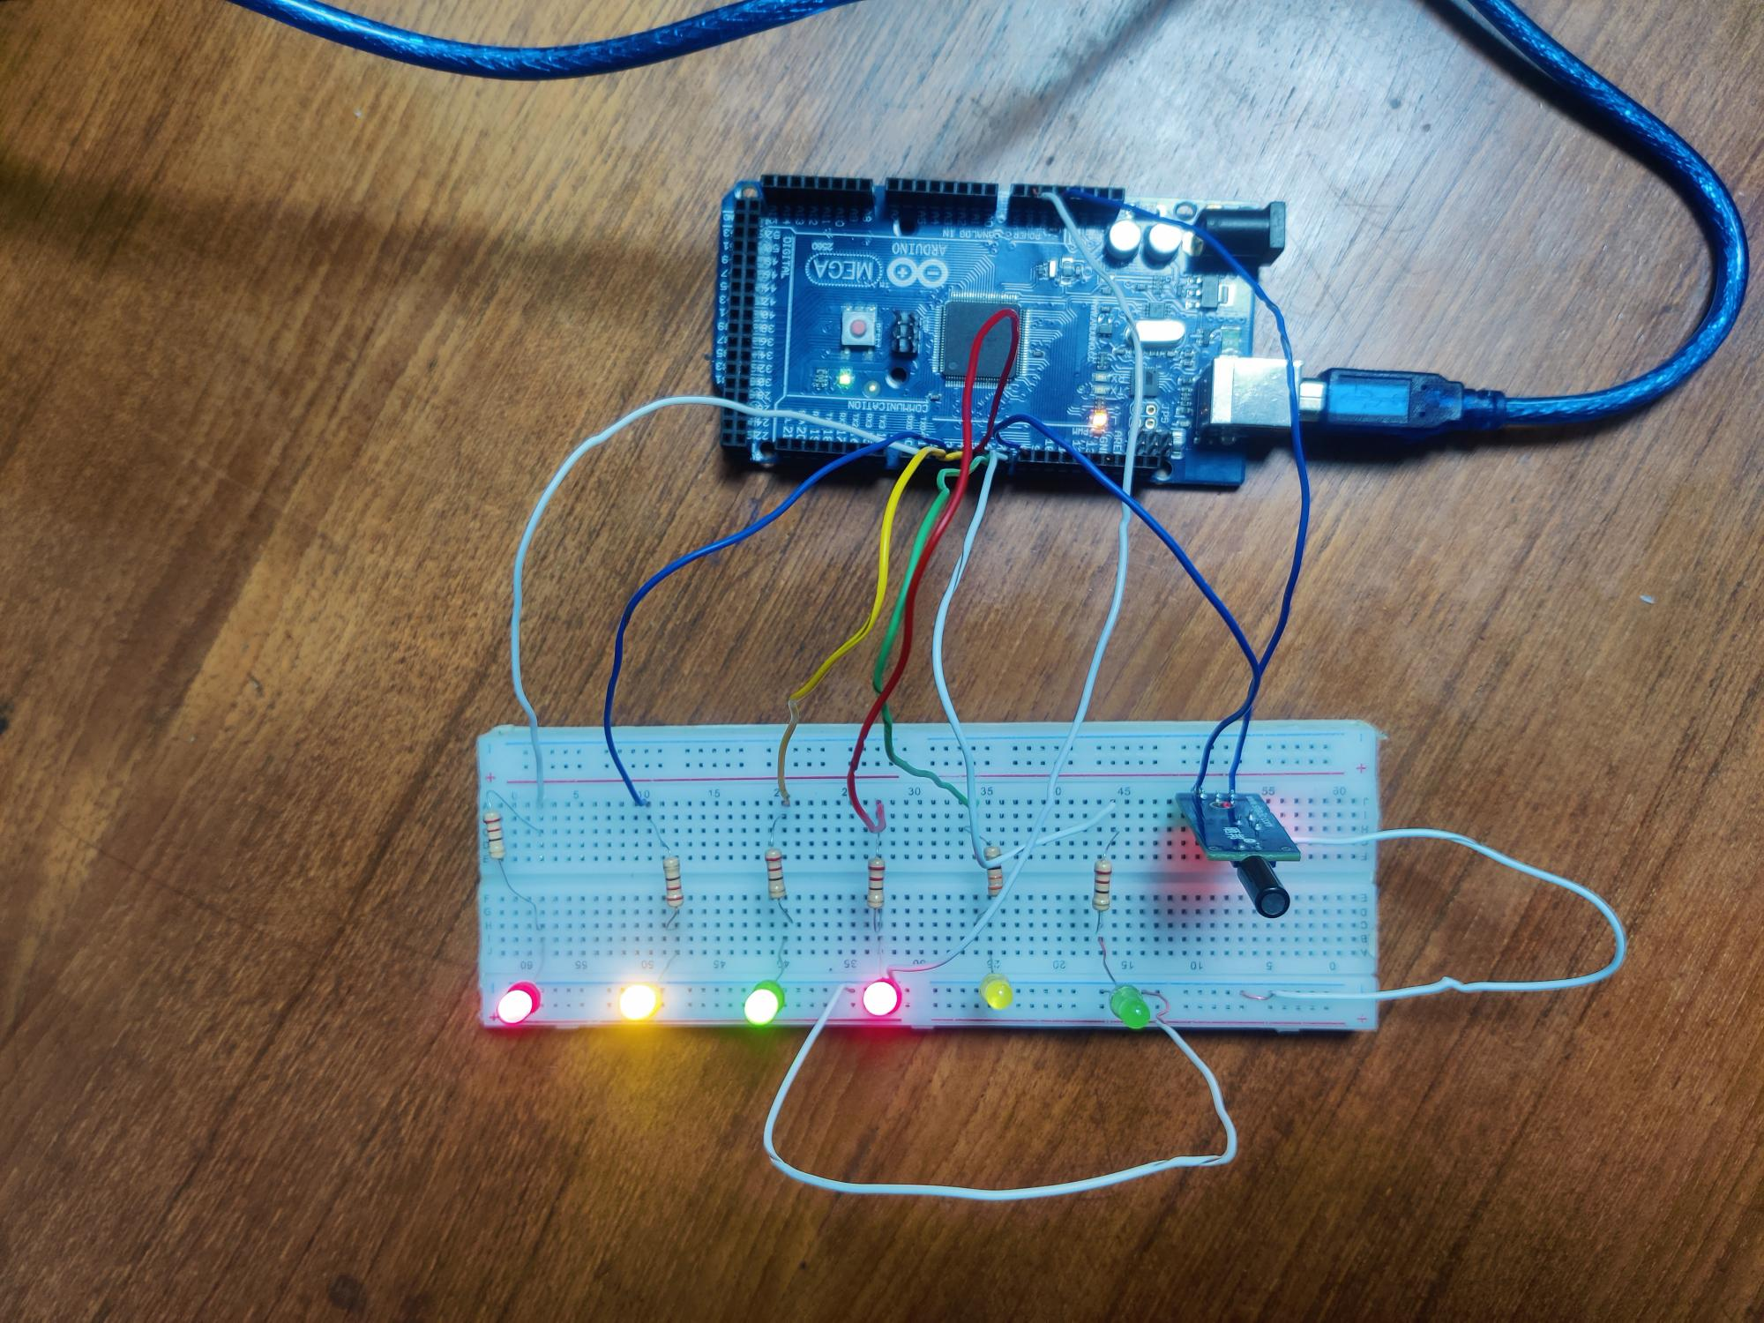

Figure: 4th LED is On

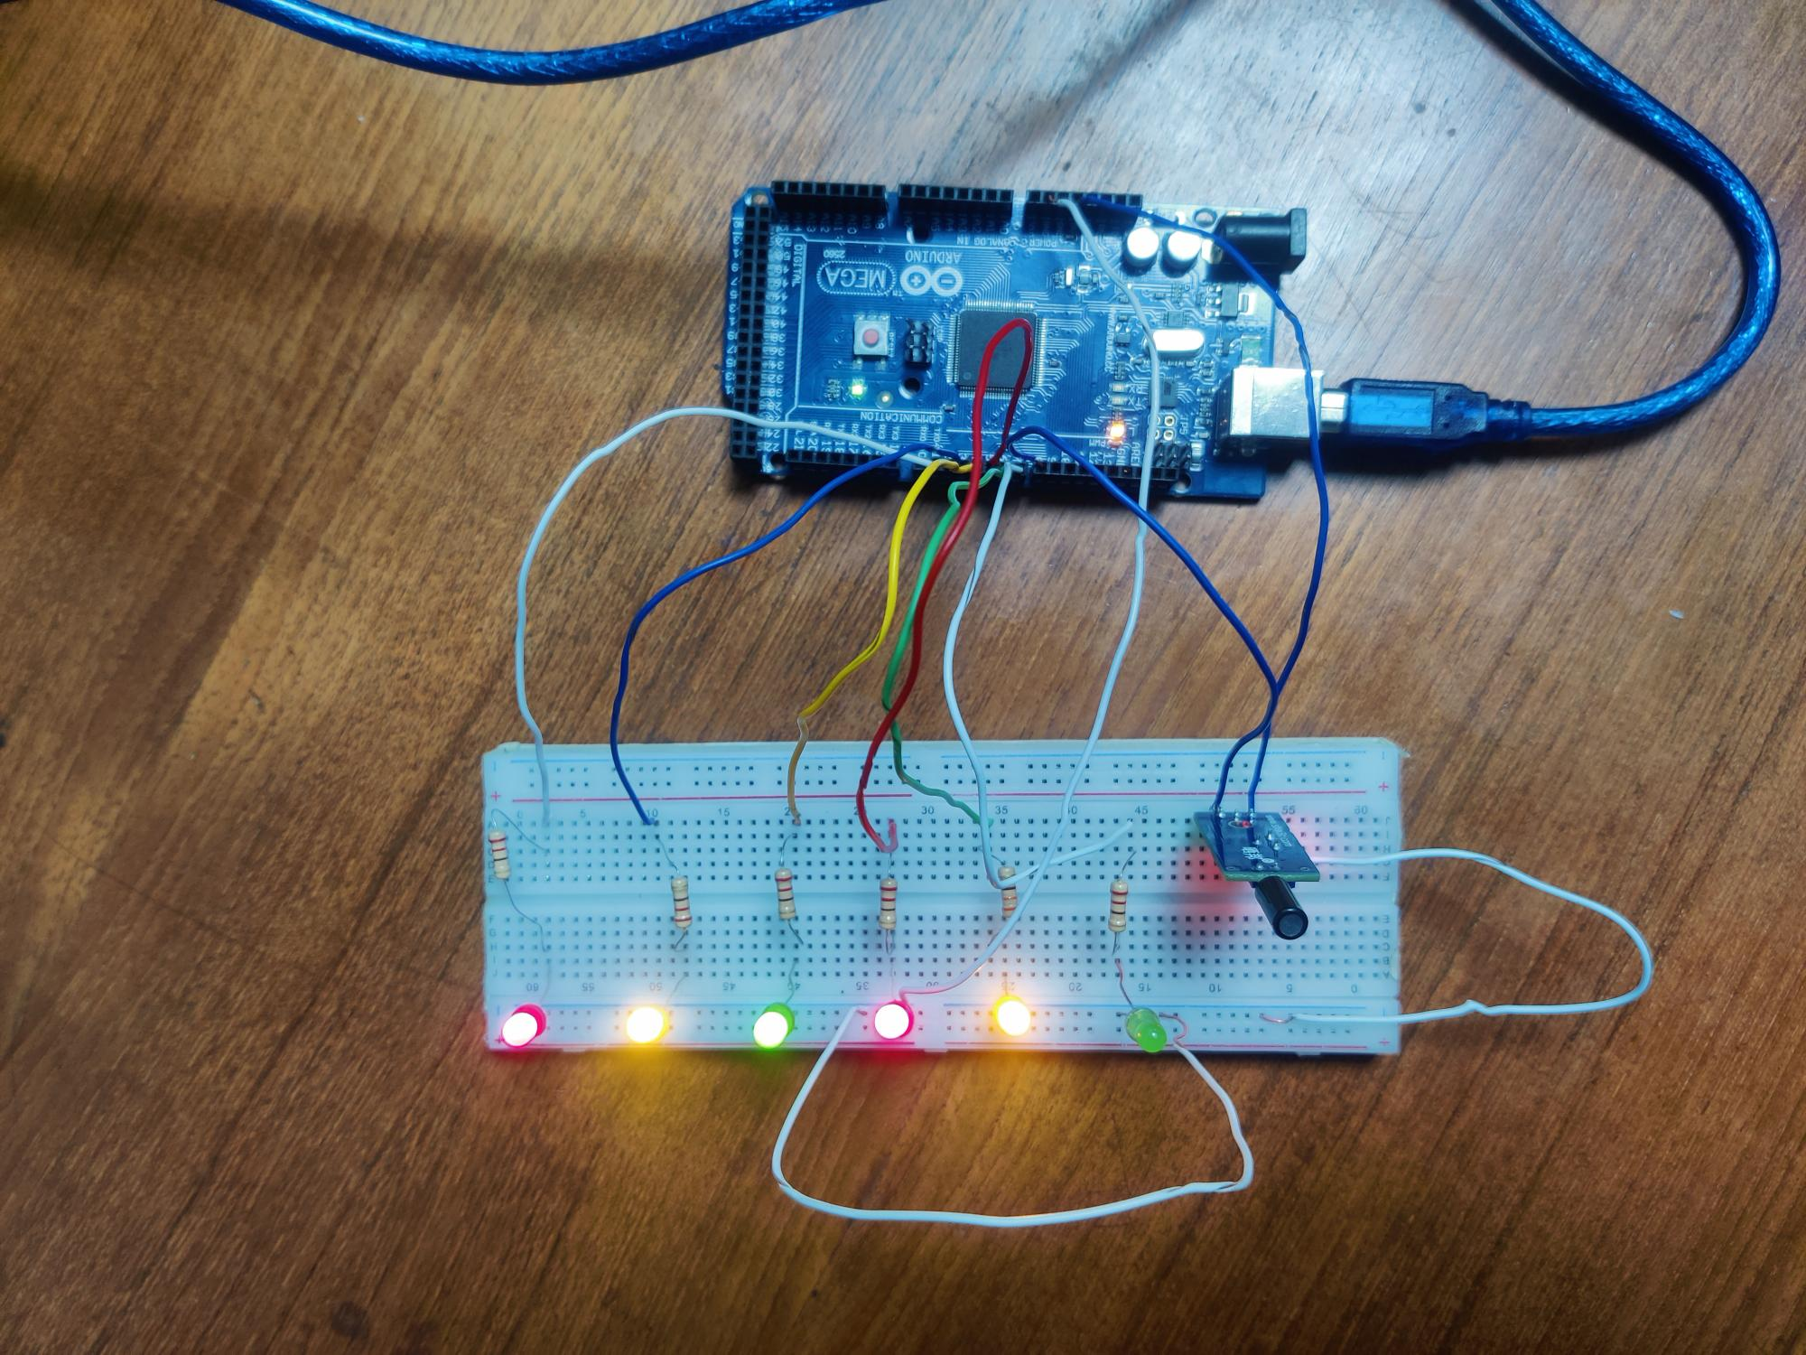

Figure: 5th LED is On

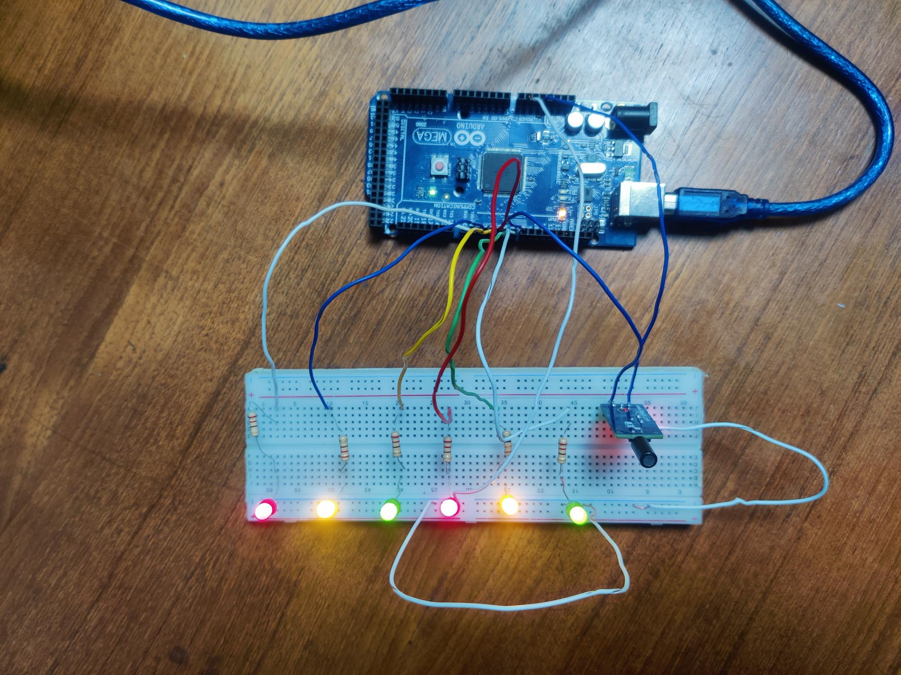

Figure: 6th LED is On

**Report:**

All codes, scripts and proteus simulation of the blink program and traffic light system is attached above.



